**Name: __________________________  
Date: ___________________________**

**Lesson 2-9: Volume of Pyramids and Cones**

**Learning Goal: How do I find the volume of a Pyramid and a Cone?**

**Volume of Pyramids**

The volume of a pyramid can be found using the following formula:  
 **It can also be written as: V = ______________________**



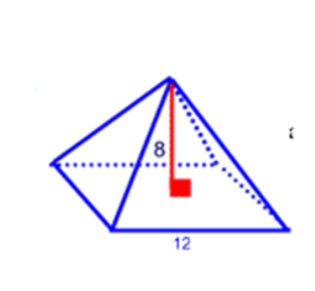**Watch Me!**

**Example 1:** Below is a regular pyramid. Find the volume to the nearest cubic unit.

**Volume of Cones**

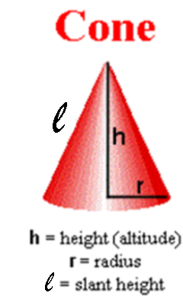The volume of a cone can be found using the following formula:

**V = _____________________**

**How are cones and pyramids similar? How are they different?**

**Example 2:** The base of a cone has a radius of 7 inches. The height of the cone is 5 inches. Find the volume of the cone. **Round your answer to the nearest 10th of a cubic centimeter**.

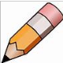**You Try!**

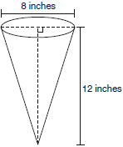**Example 3:** In the diagram below, a right circular cone has a diameter of 8 inches and a height of 12 inches.

What is the volume of the cone to the *nearest cubic inch*?

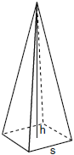**Example 4:** A regular pyramid with a square base is shown in the diagram to the left. A side, *s*, of the base of the pyramid is 12 meters, and the height, *h*, is 42 meters. What is the volume of the pyramid, *to the nearest cubic meter*?

**Sign onto Google Classroom and submit your answers to the following two questions!**

**Example 5:** Find the volume of the cone to the nearest 100th of a unit.

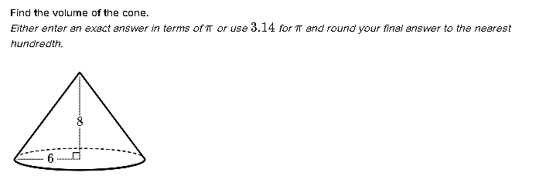

**Example 6:** Find the volume of the pyramid to the nearest 10th of a unit.

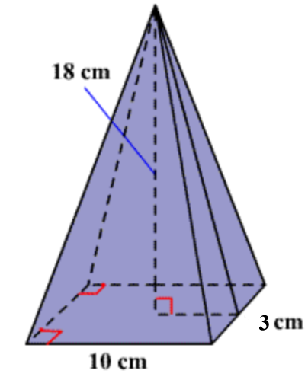

**Name: __________________________  
Date: ___________________________**

**Lesson 2-9: Homework**

1. The base of a pyramid is a rectangle with a width of 6 cm and a length of 8 cm. If the volume is 288cm3, find the height, in centimeters, of the pyramid.

1. 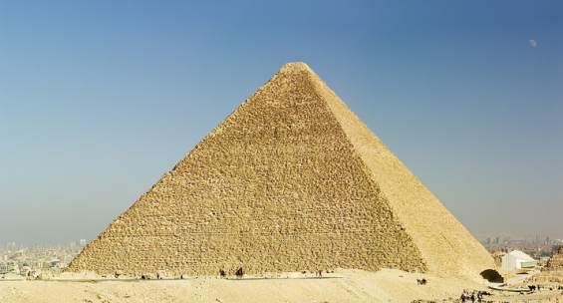The largest pyramid in the world was built around 2500 B.C. by Khufu, or Cheops, a king of ancient Egypt. The pyramid had a square base of 230 meters on each side, and a height of 147 meters. Find the volume of Cheops’ pyramid.

1. If the volume of a cone is 4000 ft3 and the height is 25.4 ft., find the radius of the base.
2. **Error Analysis -- Consider the following student work:**

**Question:** Larry is shipping a package in a cardboard box that measures 9.5 inches long, 13 inches high and 7 inches wide. He would like to wrap the box with paper. How much paper does Larry need?

**Student Answer:**

V = 9.5 x 13 x 7

=123.5 x 7

= 864

Larry will need 864.5 square inches of paper  
to wrap the cardboard box.

Your Correction:

1. **What mistake(s) did the student make above?**

1. **Correct the error and perform the question the right way!**
2. **Error Analysis -- Consider the following student work:**

**Question:** The volume of the pyramid is 448 in3, the length of the base is 12 inches and the width of the base is 8 inches. What is the height?

**Student Answer:**

V = $(\frac{1}{3})$ l x w x h

= $(\frac{1}{3})$ (12)(8) h

= 32 h

The height is 32 inches.

Your Correction:

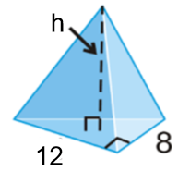

1. **What mistake(s) did the student make below?**

1. **Correct the error and perform the question the right way!**